

C0628 – Extension to CO308 Ref Circuit References

This document has been approved by

Laurence_Chapman
Solution owner or accountable role
30/03/21
Date

Document Revision History
Revision | Date | Author | Remarks
A1 | 30/03/21 | LACH | Custom specification written – first Revision

Table of Contents
1 Purpose and Guidance 4
2 Open Issues/Decisions Required 5
3 Business Requirements and References 6
4 Solution Description 7
4.1 Description 7
4.2 Custom Field Requirement 8
5 Delimitations 9
6 Translations 10
7 Go Live Information/Upgrade Issues 11
8 Performance Considerations 11
9 Glossary/Acronyms 12
10 Change log 13
10.1 Change log for revision XX 13

Purpose and Guidance
This document specifies how the defined functions shall be developed or how the application shall be customized to solve the business requirements.

The Solution Description defines what will be delivered. The solution is matched against the requirements described in the Requirements section.
The Delimitations describe what is explicitly not covered by this customization. Together with the Solution description, these sections delimit the extent of the functional addition agreed for implementation.

Open Issues/Decisions Required
This specification cannot be completed until the following issues/decisions have been resolved:
Issue/Decision | Responsible

Business Requirements and References
Business requirements, references, sources and relations to other customizations are defined in Business requirement specification:
Document No | Rev | Document Name | Comments
CO308/309 | A2 | Circuit Reference CF and Report

Solution Description

Description
Currently there are some issues around the up-revision of Engineering and Manufacturing BOMs and the Circuit Reference fields of CO308 holding their value. The first issue is that the Circuit References are lost when up-revising the Consists Of tab of the Engineering Part Revision screen (aka the “Engineering BOM”):

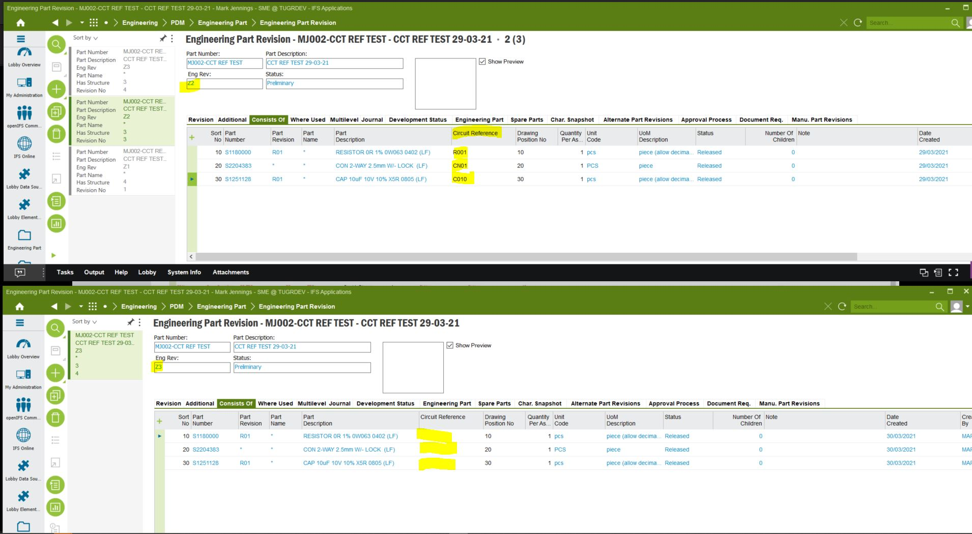

Please see image above. The Part has gone from Eng Part Rev: Z2 to Eng Part Rev: Z3 but the Circuit References have been lost on the duplicated lines. This makes it much more difficult to make small (or larger) changes to the Engineering BOM as the Circuit Reference data must be manually re-entered.

Please can this be changed so that the Circuit Reference data contained in the Circuit Reference custom field is pulled through as duplicate to the new up-revised Engineering Part Revision.

The other issue is that the Circuit Reference field in the Product Structure screen is immutable. (The data in this custom field is pulled through from the Eng Part Rev on Engineering Revision Transfer.) Please can the Circuit Reference fields in the Product Structure be made editable immediately after Engineering Transfer. Hence the connection to the “driver” custom field of the Eng Part Rev will be broken. This will allow for correction of small errors in the Manufacturing BOM of the Product Structure.

Custom Field Requirement

Field definition
DB Column Name (if known) | Field Label | Insert | Mandatory | Update | Queryable | Zoom | Uppercase | List of Value | Format & Length | Comment and Reference
 |  | Y | N | Y | Y | N | N | Y |  | .

Delimitations
The modification in this specification will be developed explicitly as written. Requests for changes in the modification necessary to fulfil (or prepare for future fulfilment of) any requirements not explicitly described in the specification, will be considered outside the scope of this modification.
Translations other than stated under chapter translations are not included in the scope for this specification.
Customer IFS permission sets will be managed by the customer, unless as stated in a revision to this Functional Specification the customer requests new permission sets to be built to enable control of the customisation’s functionality.
Customer IFS profiles will be managed by the customer.
Changes or extensions on Online Help (F1 Help), e-learning material or process models are excluded from this specification.

Translations

Prog Text | Translation | Window/form (optional) | Comment

Go Live Information/Upgrade Issues
Not Applicable.

Performance Considerations
The custom field should not hinder performance in reference to decreasing user performance and screen population time.

Glossary/Acronyms
Commonly used IFS terms within this specification include:
Term | Explanation
LOV | List of Values. This refers to a source list of records from which to select in a form.
RMB | Right Mouse Button. Commonly used abbreviation
LHS | Left hand side
RHS | Right hand side

Change log
Guidance: Delete section if no changes

Change log for revision XX

Guideline: Describe why the change order is needed (high level), and the sections of design affected by the changes. For lengthy specs, tag or mark the changed sections.

Change # | Chapter | Description of the change
1
2
3
n | 3.2 | <New column Z added to existing window>

Detailed description of Change #1

Detailed description of Change #n

TECHNICAL IMPLEMENTATION
Custom Fields

Copy Circuit Reference
Window: Engineering/PDM/Engineering Part/Engineering Part Revision

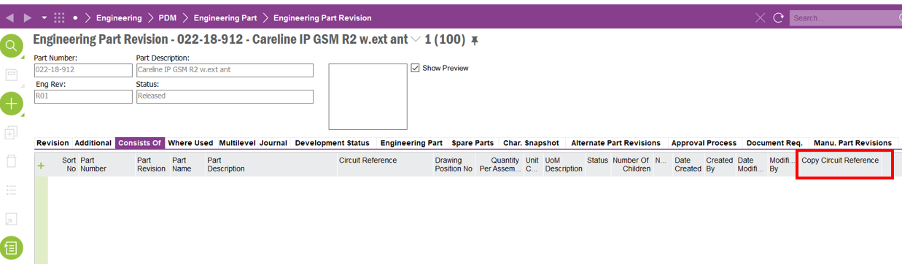

Note: It is not required for this field to be visible to the customer. Add the field to the table window and hide if required.

Custom Menus
1. Enable Circuit Ref and Copy
2. Paste Circuit Reference
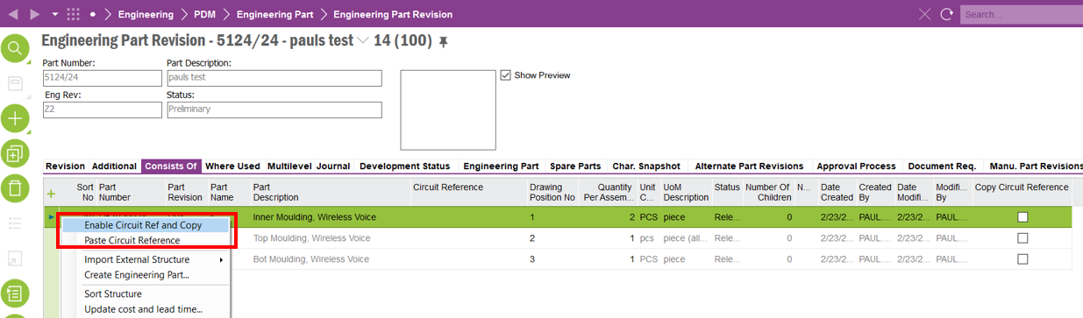

Custom Events
1. COPY_CIRCUIT_REFERENCE : This event copies circuit references of part structures from the previous revision to the new new revision
2. UPDATE_CREATED_FROM : This event raises an error when copy circuit reference is enabled for engineering parts of more than one revision

